MZC/MZA/MZK/MZX500A
FAST DIODE MODULE

Features
IT(AV) 500A
V_{DRM/}V_{RRM} 600~1600 V I_{TSM} 8.3KA
I²T 351KA²S

Isolated mounting base 2500V Compact structure and light weight savings
Full crimping structure, super temperature characteristics and power cycle capability Application
AC/DC Motor Control
Various rectifying power suplliers Industry Heating Regulation Light Dimming
Contactless Switches Motor Soft Start Welding Device Converter

Symb. |  | parameter | Test Conditions | TJ(℃) | Value | Unit
Current Ratings | IF(AV) | average on-state current | 180°half sine wave 50Hz Single side cooled Tc=60°C | 140 | 400 | A
 | IF(RMS) | RMS on-state current |  | 140 | 628 | A
 | IFSM | Surge on-state current | 10ms half sine wave V_{R}=0.6VRRM | 140 | 8.3 | KA
 | I²t | I2T for fusing coordination |  | 140 | 351 | KA²S
Characteristics | VRRM | Repetitive peak reverse voltage | V_{RRM} tp=10ms  V_{RSM}= V_{RRM}+200V | 140 | 600-1600 | V
 | IRRM | Repetitive peak reverse current | VRM= VRRM | 140 | Max.70 | mA
 | VFO | Threshold voltage |  | 140 | Max.0.85 | V
 | VFM | Peak on-state voltage | I_{FM}=1200A | 25 | Max.1.90 | V
 | r_{F} | On-state slop resistance |  | 140 | Max.0.68 | mΩ
 | trr | Reverse recovery time | I_{FM}=300A,tp=1000μs,  -di/dt=20A/μs, VR=50V | 140 | Typ.4.0 | μs

Thermal &Mechanical Data

Symb. | parameter | Test Conditions | Value | Unit
Rth(j-c) | Thermal resistance Junction to case | single side cooled | Max.0.130 | ℃/W
Rth(c-h) | Thermal resistance case to heat sink | single side cooled | / | ℃/W
F_{m} | Thermal connection torque(M5) |  | Typ.12 | N·m
 | Mounting force (M6) |  | Typ.6 | N·m
Tstg | Stored temperature |  | -40-+140 | ℃
W_{t} | Weight |  | 1820 | g

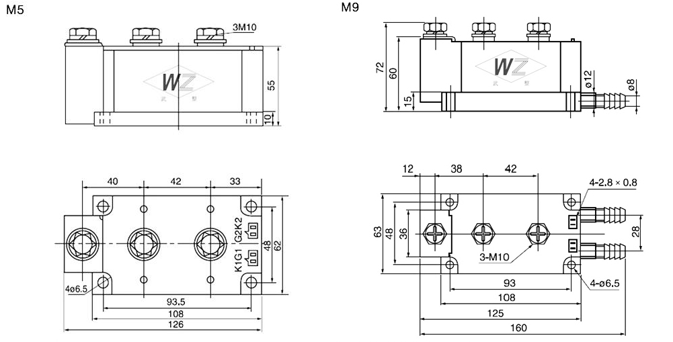
Outline：

AS Electronic Co., Ltd
Email: tomdiode@163.com
Web: www.tomdiode.com/

